EXPERIMENT 5
Implementation of Various Scheduling Mechanisms Using an Open-Source Cloud Simulator

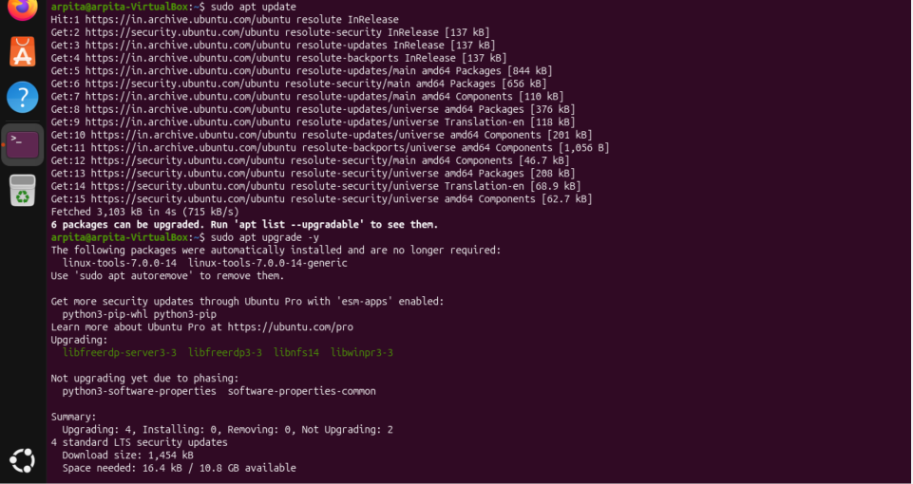
- Update Ubuntu

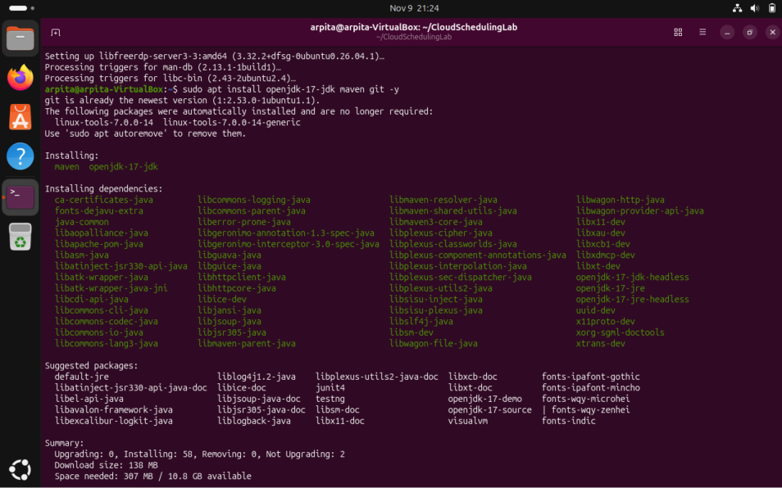
- Install Java, Maven and Git

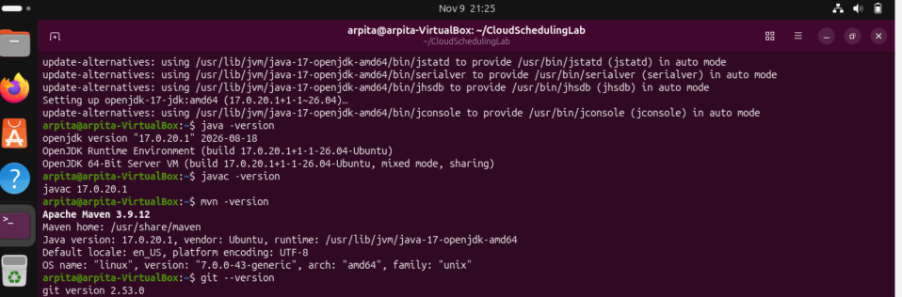

- Create The CloudSim Plus Maven Project
  - Create Folders
  - Create pom.xml
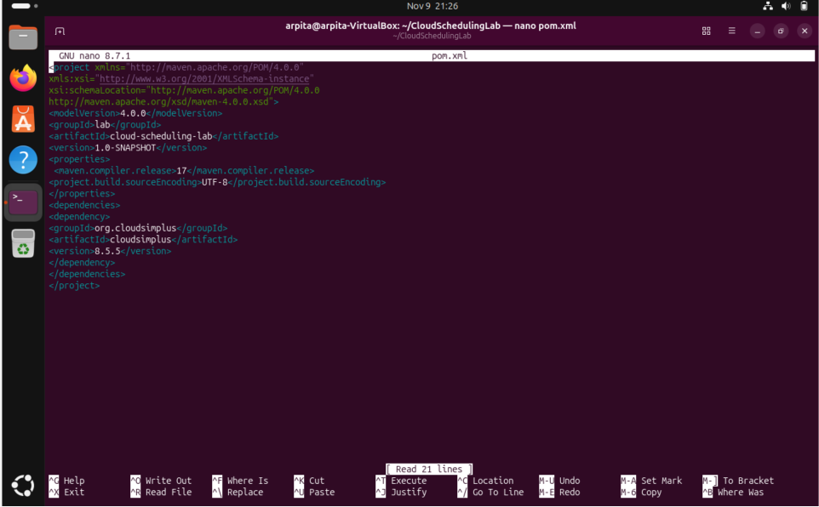

  - Resolve dependencies

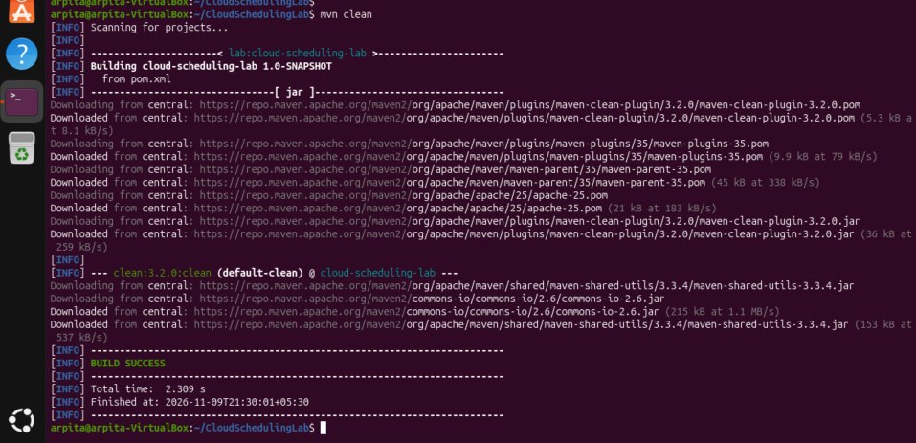
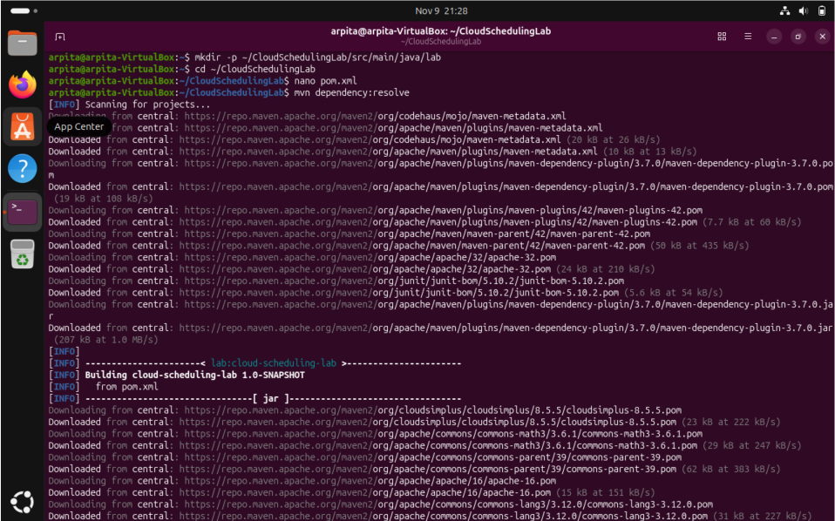
- Implement the experiment
nano src/main/java/lab/SchedulingExperiment.java
Why: Creates the Java source file containing the simulation setup, scheduler configurations and output code.
package lab;

import java.util.ArrayList;
import java.util.List;

import org.cloudsimplus.core.CloudSimPlus;
import org.cloudsimplus.datacenters.Datacenter;
import org.cloudsimplus.datacenters.DatacenterSimple;
import org.cloudsimplus.brokers.DatacenterBroker;
import org.cloudsimplus.brokers.DatacenterBrokerSimple;
import org.cloudsimplus.cloudlets.Cloudlet;
import org.cloudsimplus.cloudlets.CloudletSimple;
import org.cloudsimplus.hosts.Host;
import org.cloudsimplus.hosts.HostSimple;
import org.cloudsimplus.resources.Pe;
import org.cloudsimplus.resources.PeSimple;
import org.cloudsimplus.schedulers.cloudlet.CloudletScheduler;
import org.cloudsimplus.schedulers.cloudlet.CloudletSchedulerSpaceShared;
import org.cloudsimplus.schedulers.cloudlet.CloudletSchedulerTimeShared;
import org.cloudsimplus.schedulers.vm.VmScheduler;
import org.cloudsimplus.schedulers.vm.VmSchedulerSpaceShared;
import org.cloudsimplus.schedulers.vm.VmSchedulerTimeShared;
import org.cloudsimplus.utilizationmodels.UtilizationModel;
import org.cloudsimplus.utilizationmodels.UtilizationModelFull;
import org.cloudsimplus.vms.Vm;
import org.cloudsimplus.vms.VmSimple;
import org.cloudsimplus.provisioners.ResourceProvisionerSimple;
import org.cloudsimplus.allocationpolicies.VmAllocationPolicySimple;

public class SchedulingExperiment {

private static final int HOST_PES = 4;
private static final int VM_COUNT = 2;
private static final int CLOUDLET_COUNT = 4;

private static final long MIPS = 1000;
private static final long CLOUDLET_LENGTH = 20000;

public static void main(String[] args) {

// Scenario A
runScenario(
"A: VM SpaceShared + Cloudlet SpaceShared",
new VmSchedulerSpaceShared(),
new CloudletSchedulerSpaceShared()
);

// Scenario B
runScenario(
"B: VM SpaceShared + Cloudlet TimeShared",
new VmSchedulerSpaceShared(),
new CloudletSchedulerTimeShared()
);

// Scenario C
runScenario(
"C: VM TimeShared + Cloudlet SpaceShared",
new VmSchedulerTimeShared(),
new CloudletSchedulerSpaceShared()
);

// Scenario D
runScenario(
"D: VM TimeShared + Cloudlet TimeShared",
new VmSchedulerTimeShared(),
new CloudletSchedulerTimeShared()
);
}

// Execute individual scheduling scenario
private static void runScenario(
String title,
VmScheduler vmScheduler,
CloudletScheduler cloudletScheduler) {

System.out.println("\n==============================================");
System.out.println(title);
System.out.println("==============================================");

CloudSimPlus simulation = new CloudSimPlus();

createDatacenter(simulation, vmScheduler);

DatacenterBroker broker =
new DatacenterBrokerSimple(simulation);

List<Vm> vmList = createVms(cloudletScheduler);

List<Cloudlet> cloudletList = createCloudlets();

broker.submitVmList(vmList);

broker.submitCloudletList(cloudletList);

simulation.start();

List<Cloudlet> finished =
broker.getCloudletFinishedList();

System.out.printf(
"%-10s %-10s %-12s %-12s %-12s%n",
"Cloudlet", "VM", "Status", "Start", "Finish"
);

for (Cloudlet cloudlet : finished) {

System.out.printf(
"%-10d %-10d %-12s %-12.2f %-12.2f%n",
cloudlet.getId(),
cloudlet.getVm().getId(),
cloudlet.getStatus(),
cloudlet.getStartTime(),
cloudlet.getFinishTime()
);
}

System.out.println(
"Completed Cloudlets: "
+ finished.size() + " / " + CLOUDLET_COUNT
);
}

// Create Datacenter and Host
private static Datacenter createDatacenter(
CloudSimPlus simulation,
VmScheduler vmScheduler) {

List<Pe> peList = new ArrayList<>();

for (int i = 0; i < HOST_PES; i++) {

peList.add(new PeSimple(MIPS));
}

Host host = new HostSimple(
8192,
100000,
1000000,
peList
);

host.setRamProvisioner(
new ResourceProvisionerSimple()
);

host.setBwProvisioner(
new ResourceProvisionerSimple()
);

host.setVmScheduler(vmScheduler);

List<Host> hostList = new ArrayList<>();

hostList.add(host);

return new DatacenterSimple(
simulation,
hostList,
new VmAllocationPolicySimple()
);
}

// Create Virtual Machines
private static List<Vm> createVms(
CloudletScheduler scheduler) {

List<Vm> vmList = new ArrayList<>();

for (int i = 0; i < VM_COUNT; i++) {

Vm vm = new VmSimple(i, MIPS, 2);

vm.setRam(2048)
.setBw(10000)
.setSize(10000);

// Each VM must have its own scheduler instance
CloudletScheduler vmScheduler;

if (scheduler instanceof CloudletSchedulerSpaceShared) {

vmScheduler =
new CloudletSchedulerSpaceShared();

} else {

vmScheduler =
new CloudletSchedulerTimeShared();
}

vm.setCloudletScheduler(vmScheduler);

vmList.add(vm);
}

return vmList;
}

// Create Cloudlets
private static List<Cloudlet> createCloudlets() {

List<Cloudlet> cloudletList = new ArrayList<>();

UtilizationModel utilization =
new UtilizationModelFull();

for (int i = 0; i < CLOUDLET_COUNT; i++) {

Cloudlet cloudlet = new CloudletSimple(
CLOUDLET_LENGTH,
1,
utilization
);

cloudlet.setSizes(300);

cloudletList.add(cloudlet);
}

return cloudletList;
}
}

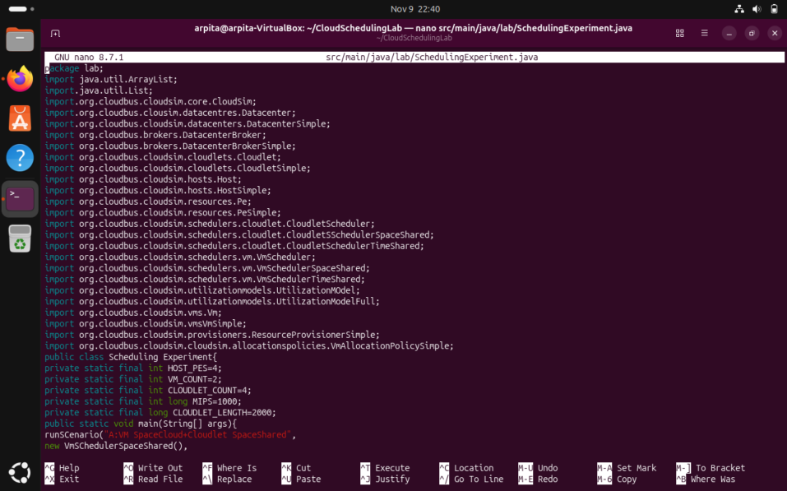

- Compile and execute
  - Compile
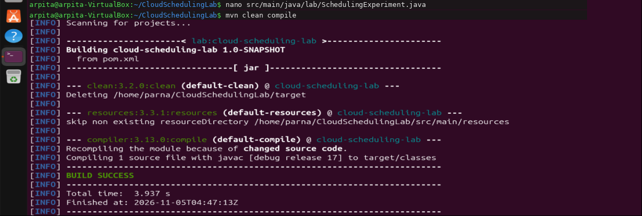
mvn clean compile

5.2 Run
mvn exec:java -Dexec.mainClass="lab.SchedulingExperiment" -Dexec.classpathScope=compile
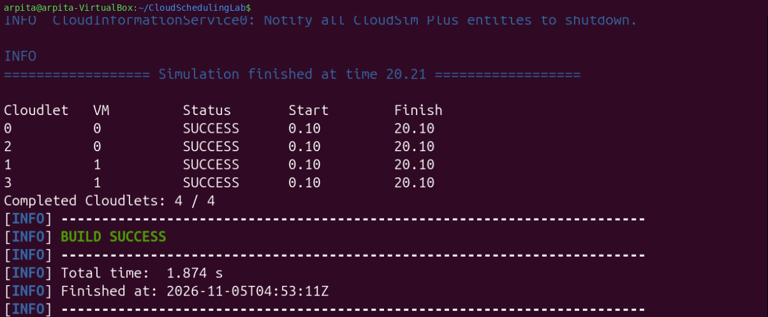
Why: Executes the main() method with Maven and the project dependency classpath.

